**pit3 引入 spring-boot-starter-data-jpa 后启动项目报错[JPA]**

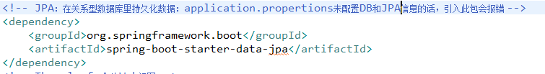

<dependency>

<groupId>org.springframework.boot</groupId>

<artifactId>spring-boot-starter-data-jpa</artifactId>

</dependency>

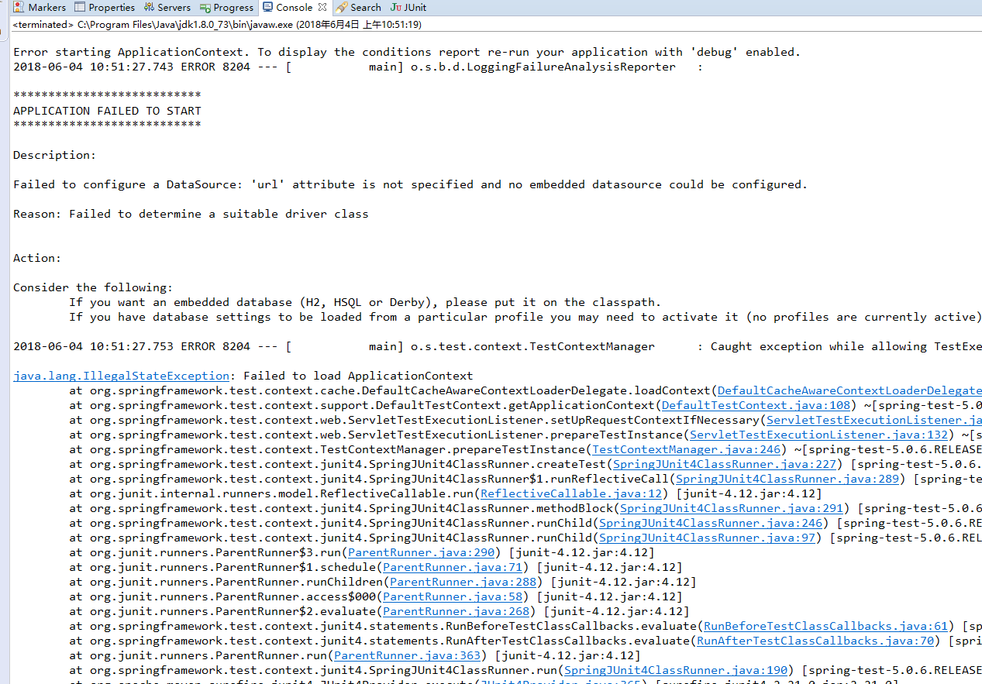

2018-06-04 10:51:27.753 ERROR 8204 --- [ main] o.s.test.context.TestContextManager : Caught exception while allowing TestExecutionListener [org.springframework.test.context.web.ServletTestExecutionListener@61322f9d] to prepare test instance [com.mutistic.boot.ApplicationTests@2d746ce4]

java.lang.IllegalStateException: Failed to load ApplicationContext

at org.springframework.test.context.cache.DefaultCacheAwareContextLoaderDelegate.loadContext(DefaultCacheAwareContextLoaderDelegate.java:125) ~[spring-test-5.0.6.RELEASE.jar:5.0.6.RELEASE]

at org.springframework.test.context.support.DefaultTestContext.getApplicationContext(DefaultTestContext.java:108) ~[spring-test-5.0.6.RELEASE.jar:5.0.6.RELEASE]

at org.springframework.test.context.web.ServletTestExecutionListener.setUpRequestContextIfNecessary(ServletTestExecutionListener.java:190) ~[spring-test-5.0.6.RELEASE.jar:5.0.6.RELEASE]

at org.springframework.test.context.web.ServletTestExecutionListener.prepareTestInstance(ServletTestExecutionListener.java:132) ~[spring-test-5.0.6.RELEASE.jar:5.0.6.RELEASE]

at org.springframework.test.context.TestContextManager.prepareTestInstance(TestContextManager.java:246) ~[spring-test-5.0.6.RELEASE.jar:5.0.6.RELEASE]

at org.springframework.test.context.junit4.SpringJUnit4ClassRunner.createTest(SpringJUnit4ClassRunner.java:227) [spring-test-5.0.6.RELEASE.jar:5.0.6.RELEASE]

at org.springframework.test.context.junit4.SpringJUnit4ClassRunner$1.runReflectiveCall(SpringJUnit4ClassRunner.java:289) [spring-test-5.0.6.RELEASE.jar:5.0.6.RELEASE]

at org.junit.internal.runners.model.ReflectiveCallable.run(ReflectiveCallable.java:12) [junit-4.12.jar:4.12]

at org.springframework.test.context.junit4.SpringJUnit4ClassRunner.methodBlock(SpringJUnit4ClassRunner.java:291) [spring-test-5.0.6.RELEASE.jar:5.0.6.RELEASE]

at org.springframework.test.context.junit4.SpringJUnit4ClassRunner.runChild(SpringJUnit4ClassRunner.java:246) [spring-test-5.0.6.RELEASE.jar:5.0.6.RELEASE]

at org.springframework.test.context.junit4.SpringJUnit4ClassRunner.runChild(SpringJUnit4ClassRunner.java:97) [spring-test-5.0.6.RELEASE.jar:5.0.6.RELEASE]

at org.junit.runners.ParentRunner$3.run(ParentRunner.java:290) [junit-4.12.jar:4.12]

at org.junit.runners.ParentRunner$1.schedule(ParentRunner.java:71) [junit-4.12.jar:4.12]

at org.junit.runners.ParentRunner.runChildren(ParentRunner.java:288) [junit-4.12.jar:4.12]

at org.junit.runners.ParentRunner.access$000(ParentRunner.java:58) [junit-4.12.jar:4.12]

at org.junit.runners.ParentRunner$2.evaluate(ParentRunner.java:268) [junit-4.12.jar:4.12]

at org.springframework.test.context.junit4.statements.RunBeforeTestClassCallbacks.evaluate(RunBeforeTestClassCallbacks.java:61) [spring-test-5.0.6.RELEASE.jar:5.0.6.RELEASE]

at org.springframework.test.context.junit4.statements.RunAfterTestClassCallbacks.evaluate(RunAfterTestClassCallbacks.java:70) [spring-test-5.0.6.RELEASE.jar:5.0.6.RELEASE]

at org.junit.runners.ParentRunner.run(ParentRunner.java:363) [junit-4.12.jar:4.12]

at org.springframework.test.context.junit4.SpringJUnit4ClassRunner.run(SpringJUnit4ClassRunner.java:190) [spring-test-5.0.6.RELEASE.jar:5.0.6.RELEASE]

at org.apache.maven.surefire.junit4.JUnit4Provider.execute(JUnit4Provider.java:365) [surefire-junit4-2.21.0.jar:2.21.0]

at org.apache.maven.surefire.junit4.JUnit4Provider.executeWithRerun(JUnit4Provider.java:273) [surefire-junit4-2.21.0.jar:2.21.0]

at org.apache.maven.surefire.junit4.JUnit4Provider.executeTestSet(JUnit4Provider.java:238) [surefire-junit4-2.21.0.jar:2.21.0]

at org.apache.maven.surefire.junit4.JUnit4Provider.invoke(JUnit4Provider.java:159) [surefire-junit4-2.21.0.jar:2.21.0]

at org.apache.maven.surefire.booter.ForkedBooter.invokeProviderInSameClassLoader(ForkedBooter.java:379) [surefire-booter-2.21.0.jar:2.21.0]

at org.apache.maven.surefire.booter.ForkedBooter.runSuitesInProcess(ForkedBooter.java:340) [surefire-booter-2.21.0.jar:2.21.0]

at org.apache.maven.surefire.booter.ForkedBooter.execute(ForkedBooter.java:125) [surefire-booter-2.21.0.jar:2.21.0]

at org.apache.maven.surefire.booter.ForkedBooter.main(ForkedBooter.java:413) [surefire-booter-2.21.0.jar:2.21.0]

Caused by: org.springframework.beans.factory.BeanCreationException: Error creating bean with name 'dataSource' defined in class path resource [org/springframework/boot/autoconfigure/jdbc/DataSourceConfiguration$Hikari.class]: Bean instantiation via factory method failed; nested exception is org.springframework.beans.BeanInstantiationException: Failed to instantiate [com.zaxxer.hikari.HikariDataSource]: Factory method 'dataSource' threw exception; nested exception is org.springframework.boot.autoconfigure.jdbc.DataSourceProperties$DataSourceBeanCreationException: Failed to determine a suitable driver class

at org.springframework.beans.factory.support.ConstructorResolver.instantiateUsingFactoryMethod(ConstructorResolver.java:587) ~[spring-beans-5.0.6.RELEASE.jar:5.0.6.RELEASE]

at org.springframework.beans.factory.support.AbstractAutowireCapableBeanFactory.instantiateUsingFactoryMethod(AbstractAutowireCapableBeanFactory.java:1254) ~[spring-beans-5.0.6.RELEASE.jar:5.0.6.RELEASE]

at org.springframework.beans.factory.support.AbstractAutowireCapableBeanFactory.createBeanInstance(AbstractAutowireCapableBeanFactory.java:1103) ~[spring-beans-5.0.6.RELEASE.jar:5.0.6.RELEASE]

at org.springframework.beans.factory.support.AbstractAutowireCapableBeanFactory.doCreateBean(AbstractAutowireCapableBeanFactory.java:541) ~[spring-beans-5.0.6.RELEASE.jar:5.0.6.RELEASE]

at org.springframework.beans.factory.support.AbstractAutowireCapableBeanFactory.createBean(AbstractAutowireCapableBeanFactory.java:501) ~[spring-beans-5.0.6.RELEASE.jar:5.0.6.RELEASE]

at org.springframework.beans.factory.support.AbstractBeanFactory.lambda$doGetBean$0(AbstractBeanFactory.java:317) ~[spring-beans-5.0.6.RELEASE.jar:5.0.6.RELEASE]

at org.springframework.beans.factory.support.DefaultSingletonBeanRegistry.getSingleton(DefaultSingletonBeanRegistry.java:228) ~[spring-beans-5.0.6.RELEASE.jar:5.0.6.RELEASE]

at org.springframework.beans.factory.support.AbstractBeanFactory.doGetBean(AbstractBeanFactory.java:315) ~[spring-beans-5.0.6.RELEASE.jar:5.0.6.RELEASE]

at org.springframework.beans.factory.support.AbstractBeanFactory.getBean(AbstractBeanFactory.java:199) ~[spring-beans-5.0.6.RELEASE.jar:5.0.6.RELEASE]

at org.springframework.beans.factory.support.DefaultListableBeanFactory.preInstantiateSingletons(DefaultListableBeanFactory.java:760) ~[spring-beans-5.0.6.RELEASE.jar:5.0.6.RELEASE]

at org.springframework.context.support.AbstractApplicationContext.finishBeanFactoryInitialization(AbstractApplicationContext.java:869) ~[spring-context-5.0.6.RELEASE.jar:5.0.6.RELEASE]

at org.springframework.context.support.AbstractApplicationContext.refresh(AbstractApplicationContext.java:550) ~[spring-context-5.0.6.RELEASE.jar:5.0.6.RELEASE]

at org.springframework.boot.SpringApplication.refresh(SpringApplication.java:759) ~[spring-boot-2.0.2.RELEASE.jar:2.0.2.RELEASE]

at org.springframework.boot.SpringApplication.refreshContext(SpringApplication.java:395) ~[spring-boot-2.0.2.RELEASE.jar:2.0.2.RELEASE]

at org.springframework.boot.SpringApplication.run(SpringApplication.java:327) ~[spring-boot-2.0.2.RELEASE.jar:2.0.2.RELEASE]

at org.springframework.boot.test.context.SpringBootContextLoader.loadContext(SpringBootContextLoader.java:139) ~[spring-boot-test-2.0.2.RELEASE.jar:2.0.2.RELEASE]

at org.springframework.test.context.cache.DefaultCacheAwareContextLoaderDelegate.loadContextInternal(DefaultCacheAwareContextLoaderDelegate.java:99) ~[spring-test-5.0.6.RELEASE.jar:5.0.6.RELEASE]

at org.springframework.test.context.cache.DefaultCacheAwareContextLoaderDelegate.loadContext(DefaultCacheAwareContextLoaderDelegate.java:117) ~[spring-test-5.0.6.RELEASE.jar:5.0.6.RELEASE]

... 27 common frames omitted

Caused by: org.springframework.beans.BeanInstantiationException: Failed to instantiate [com.zaxxer.hikari.HikariDataSource]: Factory method 'dataSource' threw exception; nested exception is org.springframework.boot.autoconfigure.jdbc.DataSourceProperties$DataSourceBeanCreationException: Failed to determine a suitable driver class

at org.springframework.beans.factory.support.SimpleInstantiationStrategy.instantiate(SimpleInstantiationStrategy.java:185) ~[spring-beans-5.0.6.RELEASE.jar:5.0.6.RELEASE]

at org.springframework.beans.factory.support.ConstructorResolver.instantiateUsingFactoryMethod(ConstructorResolver.java:579) ~[spring-beans-5.0.6.RELEASE.jar:5.0.6.RELEASE]

... 44 common frames omitted

Caused by: org.springframework.boot.autoconfigure.jdbc.DataSourceProperties$DataSourceBeanCreationException: Failed to determine a suitable driver class

at org.springframework.boot.autoconfigure.jdbc.DataSourceProperties.determineDriverClassName(DataSourceProperties.java:236) ~[spring-boot-autoconfigure-2.0.2.RELEASE.jar:2.0.2.RELEASE]

at org.springframework.boot.autoconfigure.jdbc.DataSourceProperties.initializeDataSourceBuilder(DataSourceProperties.java:176) ~[spring-boot-autoconfigure-2.0.2.RELEASE.jar:2.0.2.RELEASE]

at org.springframework.boot.autoconfigure.jdbc.DataSourceConfiguration.createDataSource(DataSourceConfiguration.java:43) ~[spring-boot-autoconfigure-2.0.2.RELEASE.jar:2.0.2.RELEASE]

at org.springframework.boot.autoconfigure.jdbc.DataSourceConfiguration$Hikari.dataSource(DataSourceConfiguration.java:81) ~[spring-boot-autoconfigure-2.0.2.RELEASE.jar:2.0.2.RELEASE]

at sun.reflect.NativeMethodAccessorImpl.invoke0(Native Method) ~[na:1.8.0_73]

at sun.reflect.NativeMethodAccessorImpl.invoke(NativeMethodAccessorImpl.java:62) ~[na:1.8.0_73]

at sun.reflect.DelegatingMethodAccessorImpl.invoke(DelegatingMethodAccessorImpl.java:43) ~[na:1.8.0_73]

at java.lang.reflect.Method.invoke(Method.java:497) ~[na:1.8.0_73]

at org.springframework.beans.factory.support.SimpleInstantiationStrategy.instantiate(SimpleInstantiationStrategy.java:154) ~[spring-beans-5.0.6.RELEASE.jar:5.0.6.RELEASE]

... 45 common frames omitted

[ERROR] Tests run: 1, Failures: 0, Errors: 1, Skipped: 0, Time elapsed: 3.477 s <<< FAILURE! - in com.mutistic.boot.ApplicationTests

[ERROR] contextLoads(com.mutistic.boot.ApplicationTests) Time elapsed: 0.009 s <<< ERROR!

java.lang.IllegalStateException: Failed to load ApplicationContext

Caused by: org.springframework.beans.factory.BeanCreationException: Error creating bean with name 'dataSource' defined in class path resource [org/springframework/boot/autoconfigure/jdbc/DataSourceConfiguration$Hikari.class]: Bean instantiation via factory method failed; nested exception is org.springframework.beans.BeanInstantiationException: Failed to instantiate [com.zaxxer.hikari.HikariDataSource]: Factory method 'dataSource' threw exception; nested exception is org.springframework.boot.autoconfigure.jdbc.DataSourceProperties$DataSourceBeanCreationException: Failed to determine a suitable driver class

Caused by: org.springframework.beans.BeanInstantiationException: Failed to instantiate [com.zaxxer.hikari.HikariDataSource]: Factory method 'dataSource' threw exception; nested exception is org.springframework.boot.autoconfigure.jdbc.DataSourceProperties$DataSourceBeanCreationException: Failed to determine a suitable driver class

Caused by: org.springframework.boot.autoconfigure.jdbc.DataSourceProperties$DataSourceBeanCreationException: Failed to determine a suitable driver class

**问题描述：**spring boot 项目 引入 spring-boot-starter-data-jpa 使用maven install 或 启动 Application主类时，报错

**解决方案：**

application.properties 添加 DB和JPA配置信息

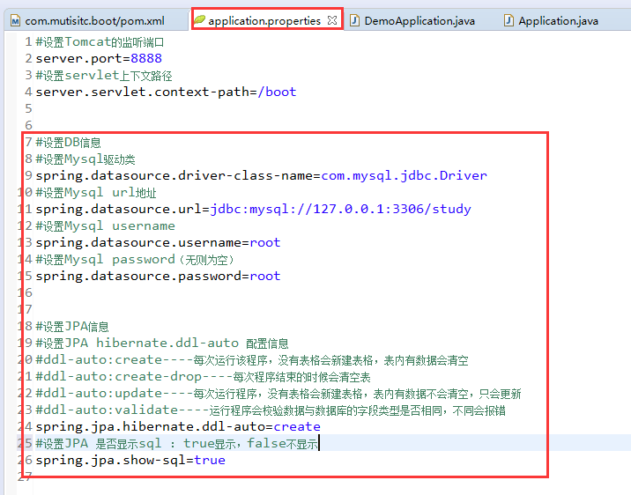

#设置DB信息

#设置Mysql驱动类

spring.datasource.driver-class-name=com.mysql.jdbc.Driver

#设置Mysql url地址

spring.datasource.url=jdbc:mysql://127.0.0.1:3306/study

#设置Mysql username

spring.datasource.username=root

#设置Mysql password（无则为空）

spring.datasource.password=root

#设置JPA信息

#设置JPA hibernate.ddl-auto 配置信息

#ddl-auto:create----每次运行该程序，没有表格会新建表格，表内有数据会清空

#ddl-auto:create-drop----每次程序结束的时候会清空表

#ddl-auto:update----每次运行程序，没有表格会新建表格，表内有数据不会清空，只会更新

#ddl-auto:validate----运行程序会校验数据与数据库的字段类型是否相同，不同会报错

spring.jpa.hibernate.ddl-auto=create

#设置JPA 是否显示sql ： true显示，false不显示

spring.jpa.show-sql=true